Project Design Phase-II
Technology Stack (Architecture & Stack)

Date | 06-04-2026
Team ID | 69bd2f9cc71a9ebd6a50e3b1
Project Name | Smart library request workflow in service now
Maximum Marks | 4 Marks

Technical Architecture:
The Smart Library Request Workflow is designed using a 3-tier architecture in ServiceNow:
- Presentation Layer: ServiceNow Portal / Web UI for students and librarians
- Application Layer: ServiceNow workflows, business rules, and automation engine
- Data Layer: ServiceNow database (tables for users, books, requests, transactions)
Guidelines:
- User logs into ServiceNow portal
- Searches for books and checks availability
- Raises a book request
- Request goes to librarian for approval
- Approval/Rejection is processed
- Notification sent to user
- Book issue/return is recorded in system
External Interfaces:

- Email Notification Service
- SMS Gateway API (for alerts)
- Optional: Barcode/QR Scanner integration
Data Storage:

- ServiceNow Tables (User, Book, Request, Transaction)
- Cloud-based storage (ServiceNow platform)

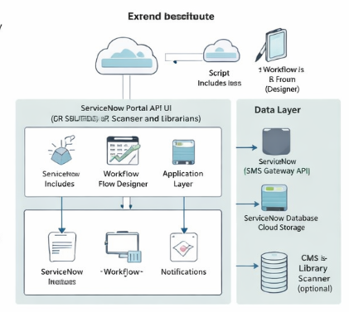

Table-1 : Components & Technologies:

S.No | Component | Description | Technology
 | User Interface | Web interface for students & librarians | ServiceNow Portal, HTML, CSS, JavaScript
 | Application Logic-1 | Book search and availability logic | ServiceNow Script Includes, Glide API
 | Application Logic-2 | Request workflow and approval process | ServiceNow Flow Designer / Workflow
 | Application Logic-3 | Notification and alert system | ServiceNow Notifications, Email API
 | Database | Stores users, books, requests data | ServiceNow Tables (Glide DB)
 | Cloud Database | Cloud-based data management | ServiceNow Cloud Platform
 | File Storage | Store book details, reports | ServiceNow Attachment System
 | External API-1 | Email notification service | SMTP / ServiceNow Email Integration
 | External API-2 | SMS notification service | Twilio API / SMS Gateway
 | Machine Learning Model | Book recommendation (optional) | ServiceNow Predictive Intelligence
 | Infrastructure (Server / Cloud) | Deployment environment | ServiceNow SaaS Cloud

Table-2: Application Characteristics:
S.No | Characteristics | Description | Technology
 | Open-Source Frameworks | Uses web technologies integrated with ServiceNow | HTML, CSS, JavaScript
 | Security Implementations | Role-based access, authentication, encryption | ServiceNow ACL, OAuth, SSL Encryption
 | Scalable Architecture | 3-tier scalable architecture | ServiceNow Cloud, Microservices
 | Availability | High availability with cloud support | ServiceNow Cloud (99.9% uptime)
 | Performance | Fast response using optimized workflows | Caching, Indexed DB, Efficient Queries

References:
• https://c4model.com/
• https://developer.ibm.com/patterns/
• https://www.ibm.com/cloud/architecture/
• https://aws.amazon.com/architecture
• https://medium.com/

